Spheres of Poetic Justice
Stephen Wright

Let us begin with The End, as we are nearing the end of our conference. The End is a short story by Samuel Beckett, written in the late 1940s, the most prolific period of his writing career. Beckett is not by and large considered to be an author particularly concerned with issues of justice and injustice, though we now know the significant role he played in the French Résistance movement, a fact about which he remained characteristically discreet throughout his life. Unlike many writers of his generation, Beckett was exceptionally uninterested in denouncing injustice or in propounding any programme of redistributive justice. But in The End, we find a typically Beckettian passage which has much to say about the well-known phenomenon of the blindness, or perhaps more accurately myopia, of those seeking to broaden the spheres of justice to other forms of injustice; one injustice conceals another, or worse still, secretes another. The narrator of the passage is utterly Beckettian: superbly articulate, but utterly incapable of gaining any pragmatic perspective on himself in the world; superlatively intelligent, but somehow not of this world. This clash of perspectives – inability to hear speech acts as meaningless curiosities or to imagine himself in any intersubjective relationship with those around him – is the very basis of Beckett’s humour. The narrator of this passage is an utterly exhausted and almost dead beggar, lying prostrate on a city sidewalk, meditating. One day, he finds himself incidentally pointed out as a piece of evidence in the harangue of an orator, delivering a speech ostensibly on social injustice. At first, the narrator pays scant heed to the evocation of the usual grand principles – until he realises that he is the example. “Look at this human larva,” exclaims the activist, “barely alive, barely human, this is what our system produces, scarcely able to breathe, incapable of dreams or thought…” Etc. The inadvertent but deep-set injustice of the orator is highlighted and underscored by the very reflections of the narrator that precede it, as it could never have been through a more naturalistic and indignant discussion of exclusion and injustice. The narrator’s patent incapacity to envisage intersubjective relations underscores the activist’s own inability to do so, and the almost oneiric and signature-style repetition of “I” in the lead up is a telling case of how the invisibility of injustice is produced and perpetuated.

« Un jour j’assistai à une scène étrange. D’habitude je ne voyais pas grand’chose. Je n’entendais pas grand’chose non plus. Je ne faisais pas attention. Au fond je n’étais pas là. Au fond je crois que je n’ai jamais été nulle part. » (NTPR p. 101)

So that is The End – amongst other things, an avowal that, in the end, art can’t do much with respect to justice (or the political). And indeed, one might wonder why a session devoted to aesthetics is tacked onto the end of a conference devoted to serious philosophical issues of injustice. All the more so in that art has fallen so dramatically short of the goals it has persistently set for itself throughout modernity as to its world-transforming, and injustice-alleviating capacities. But following Becket, my proposal here is to consider the whole issue of our myopia with regard to injustice (to particular forms of injustice) , as it is an issue which engages directly the aesthetic realm, and in which art and art-related practices could conceivably play an important and heuristic role. Art, like political action, is about shifting the “partition lines” of sense-based cognition, challenging the self-evident order of perception – that is, just as in Beckett’s short story and others too, it is about making us hear as discourse what was previously heard as only noise or prattle, about seeing as fellow human beings those whom we previously saw only as shadows.

I am interested in seeing what art can do – if indeed it can do anything at all – in terms of revealing the mechanisms by which injustice is overlooked even by, and sometimes particularly by, those most desirous to alleviate it. I am interested in what Richard Sennett once searchingly referred to as “the hidden injuries of class”. Not the usual sorts of quantifiable iniquities stemming from a skewed distribution of resources (which I don’t minimise, but merely point out that they are plainly visible, though painfully persistent). I am talking about injuries so deep-set, so naturalised and embodied, as to be invisible even to those who suffer from them – making those who are victims of injustice accomplices in perpetuating the injustice. Because this problematic has to do with the invisible sphere of injustice, it would seem to me that the visual arts, with their experience in dealing with the dialectics of the visible and the invisible, might have some role to play. Art as a usefully heuristic, injustice-detection tool would of course require that art be wrested from the autonomous realm, where it is currently trapped, unable to reach those having the agency to do anything about the injustice.

So if art has to do with shifting the partition lines of the perceptible, perhaps there is a parallel to be drawn between its redistributive role in the aesthetic sphere and its potential contribution to the sphere of justice. At any event, the partition line between the visible and the invisible is upheld by the “police”. In a Foucaldian perspective, one might argue that the key issue in policing art is the question of visibility. As Jacques Rancière put it in his now classic definition,

“the police is, in its essence, the law which, though generally implicit, defines the part or lack of part of the parties involved…. The police is thus above all a bodily order that defines the partition between means of doing, means of being and means of saying, which means that certain bodies are assigned, by their very name, to such and such a place, such and such a task; it is an order of the visible and the sayable, which determines that some activities are visible and that some are not, that some speech is heard as discourse while others are heard as noise.”

Rancière’s analysis applies equally to the spheres of justice and the spheres of art, and more generally to the partition of the real between places and non places of visibility and legitimacy, and enables us to better see how actions and words are distributed in keeping with a line that has been defined a priori, an always shifting line of partition between practices that are admitted and those that are discredited, between what must be said and what cannot be said (socially mandatory and forbidden speech), between what must be seen and what cannot be. Rancière’s analysis has had a certain fortune in the art world because it has the appealing advantage of not partitioning aesthetics from the political, but of identifying a common core struggle.

Rancière’s use of the word “police” to refer to the forces that maintain a semblance of self-evidence in the existent perceptual order is useful because it draws attention to the fact that this order is enforced. Not by truncheon-wielding wardens of the law, of course, but in a far more sophisticated way, by controlling what can and cannot be said, heard or seen. This becomes particularly evident with respect to frame-related discourse (the overlapping frames of multicultural society, for instance) and the sophistication with which framing devices function.

How often do we find ourselves the unwitting apologists for injustice when, through lack of attention to concrete detail, we caution the application of broad and high-minded principles of justice, whose by-product is a still more insidious form of injustice. This is not quite the same thing as what Rancière refers to, but it is a popular variant on it and has received significant attention. Consider the following U.S. Supreme Court decision in Woodson v. North Carolina (1976):

“A process that accords no significance to relevant facets of the character and record of the individual offender or the circumstances of the particular offence excludes from consideration in fixing the ultimate punishment of death the possibility of compassionate or mitigating factors stemming from the diverse frailties of humankind. It treats all persons convicted of a designated offence not as uniquely individual human beings, but as members of a faceless, undifferentiated mass to be subjected to the blind infliction of the penalty of death.”

This eloquent and precedent-setting acknowledgement of the need for judicious spectatorship in the meting out of justice overturns the widely held idea that the cold, hard facts alone are adequate for judicial reasoning and suggests that empathetic imagining, when “tethered” to the evidence, as lawyers say, is an appropriate and indeed essential ingredient of any moral stance that is truly concerned with the good of other people whose lives are distant from our own. It is one thing, of course, to instruct courts to treat defendants not “as members of a faceless, undifferentiated mass,” but “as uniquely individual human beings,” and another thing altogether to implement policies to attain this goal. What sort of stereotype-busting, perception-deepening, or empathy-engendering tools would be appropriate? In her 1995 book, entitled Poetic Justice, Martha Nussbaum makes a compelling case for the cognitive dimension of emotion and for the role of what she calls the “literary imagination” in constituting and sustaining meaningful public rationality, discourse, and policy making, which have come to be informed almost exclusively by cost-benefit analysis. Novels, and particularly realist novels, she argues, offer good guidance of both a predictive and normative kind. Without quite saying so, Nussbaum allows us to conclude that, for instance, before a White, middle-class jury is truly able to judge a Black, inner-city violent offender in North America today, they should be given the opportunity to read, say, Richard Wright’s Native Son, to gain at least some sort of insight into what it means to live in the defendant’s world. For as she points out, “the novel determinedly introduces its reader to that which is in a way common and close at hand – but which is often, in its significant strangeness, the object of profound ignorance and emotional refusal.” Beautifully and convincingly put, I think. What is unconvincing, however, about Nussbaum’s book is the heuristic privilege she ascribes to the novel in particular and to narrative in general. Why not extend her reasoning to other forms of artistic expression – for if visual artists have not honed a full range of awareness-enriching tools throughout the history of art, they have not accomplished much at all? It is fair to say, I think, that if the real were ever to be the object of the sort of sustained attention that artworks regularly enjoy, justice would not for that be poorly served.

Hence the need for “poetic justice.” By this term, I am referring not to the well-known literary device, whereby an evil deed-doer ironically befalls a fate comparable to the ill he or she inflicted on someone else (which, though it has little to do with justice, provides basic emotional satisfaction by suggesting some sort of divine equalizing effect over the long term) but am arguing that it may be necessary first to isolate the two terms, and then reunite them in an almost literal way: when poetic, justice reasserts the role of creative activity and art-making in the moral affairs of the world. Is it meaningful to speak of “moral creativity”? And if so, what specifically can art do to enhance it?

One can only answer such questions through concrete examples but in so doing it is worthwhile considering, too, why art has so far failed to do so. Part of the reason, of course, is that because of its funding and exhibition structures, art reaches only an elite public, often preaching to the converted, rather than actively engaging in shifting the partition lines of the perceptible, however critical it may be in and of itself. Art’s reaction to this paralysing situation has been two-fold: an ostentatious stepping out into the political, seeking ways to make itself more visible, and a stealthy withdrawal from the very performative framework that confers it its artistic visibility. However, the reasons for the failure cannot be reduced to sociological contingencies, but must be sought in the immanence of the artworks themselves. How is one to lay bare the hidden injuries of partition (not merely geopolitical partition, though as we know, it is the most devastating instance of partition) if insufficient heed is paid to the ways in which the deadening logic of partition is reproduced in and by the artworks themselves? Art in particular lives partitioned from the real that it seeks to represent. Which is why many well-meaning artists, in seeking to draw attention to the injustices, the inanity, of partition in Palestine or here in India, have inadvertently ended up reproducing partition’s deadening logic, producing images of partition without adequately attending to how our partitioned times encompass all walks of contemporary human endeavour, including artistic representation. Art, of course, cannot simply wish partitioning away: its symbolic privileges and market value are upheld by an economy of scarcity, which admittedly ensures that art remains the object of particularly attentive scrutiny. Yet such artificially sustained scarcity, by protecting the highly valuable, commodified art object from the realm of mass-production and distribution (thus ensuring its exchange value), also deprive it of its use-value – that is, of its capacity to do much damage to the dominant order of signs. All which allows partitioning to pursue its work unhindered.

Again, examples are needed here, but to move things ahead, I would argue that those visual practices whose self-understanding is grounded in the conceptual art tradition may, paradoxically, because of their defining self-reflexivity, be most appropriate to contributing to poetic justice – if only the “tautological imperative” which has been their defining feature, can be unleashed. That is, instead of spinning harmlessly within the performative frame of the art world, it was unleashed in the realm of the political. Let me cite, by way of conclusion, one particularly satisfying instance of just that.

I refer to the work of the Buenos Aires, Argentina-based Grupo de Arte Callejero (Street Art Group), an artists collective which has working together with other groups and individuals – including lawyers, activists – injecting specifically artistic competence into the efforts of a very particular Argentine social movement for justice. Founded in 1997 in Buenos Aires, the eight-person group works in situations of public participation, rather than art-referenced contexts, using graphic-design and art-related competencies to challenge the public consumption and foster the public production of signs. Over the past few years, the GAC has worked with the steering committee of the H.I.J.O.S. movement (founded by the children of some of the 30,000 people those who were “disappeared” by the military dictatorship that ruled the country between 1976 and 1983), in organising public actions with the objective of drawing attention to the ongoing presence in Buenos Aires’ residential neighbourhoods of those who, in one capacity or another, took part in the criminal activities of the military government. These actions, highly specific to the Argentine context, and developed by H.I.J.O.S. in 1995, are known as “escraches”. Their watchword: Juicio y castigo, “judgement and punishment,” is reflected in the street signs that the group produces. An escrache is a sort of collective performance, where the production of memory and knowledge is inseparable from the production of form. The point is not so much to demand that the perpetrators of the genocide and political repression and injustice – which were of course not carried out by a handful of officers and their henchmen but required an extensive network of profiteers from all walks of life – be brought to trial, nor certainly to lynch them in a further miscarriage of justice, but to shed light on the role they played and their ongoing impunity, in order to constitute a sort of social memory and a popular understanding at the neighbourhood level of how the dictatorship actually functioned, so as to prevent its re-emergence. (I should add that these rather carnavalesque collective performances are planned months in advance in order to ensure that the escrachado not be present.) To this end, the GAC has developed a full array of tools – street signs indicating the location of clandestine detention centres, city maps showing the addresses of the perpetrators of repression – that the group deploys itself and makes available to others.

The GAC has chosen to inject art-specific competence into social struggles for the visibilisation of injustice as a tangible form of energy, while at the same time maintaining art as such in a state of objective absence. What they do is not art, yet without art it would not be possible to do it. Consider just one image produced for an escrache drawing attention to the so-called “flights of death” whereby victims of the regime were taken, after having been tortured, and often not yet dead, by military aircraft out over the South Atlantic Ocean and thrown out – their bodies eaten by sharks and never recovered – sometimes after being given absolution by priests on board the flights. Given the amnesia of Argentine “normalisation” such detail is not superfluous, however grizzly. The GAC produced the following image: against a yellow, diamond-shaped street sign, the contours of an airplane are stencilled in black. But inside the airplane, the shape of a human figure can be seen, but in negative, the same yellow as the sign’s background. Here we have an instance of the tautological imperative unleashed: for we are reminded of the absence (of justice, of countless lives…) both in the form and in the content, even as art avoids the logic of partitioning (which is why, too, the image I have chosen is one deliberately taken in the group’s studio, not in a performative framework).

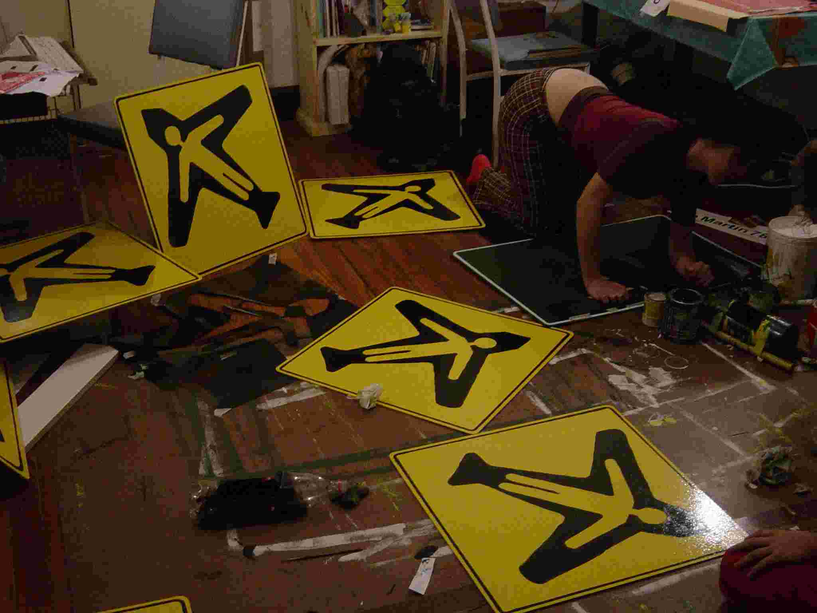

Poetic justice of a sort may be possible here because what is being done is not art, yet without art it would not be possible to do it. It is not bracketed off, yet its symbolic resonance is in no way depleted. This paradox underscores an ethical imperative: how could art adequately reconcile form and content to represent the absence of the 30,000 people assassinated by Argentina’s military regime some three decades ago, for it is not their presence which is absent, but their absence which is so devastatingly present. And that is an unhealed, still hidden injury of injustice. In such circumstances, and others too, art must have the grace to respect that absence with its own.

La Mésentente (Paris: Galilée, 1995), p. 52. Our translation.

